**Welcome to Mobility’s Hometown**

**America’s Air Mobility Training Center**

**Altus Air Force Base, Oklahoma**

**Student Reporting Instructions**

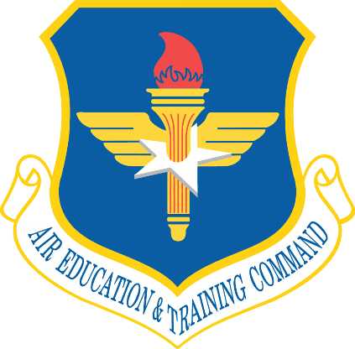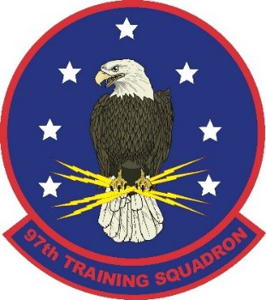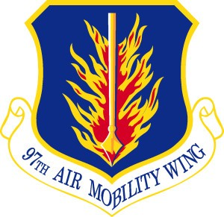

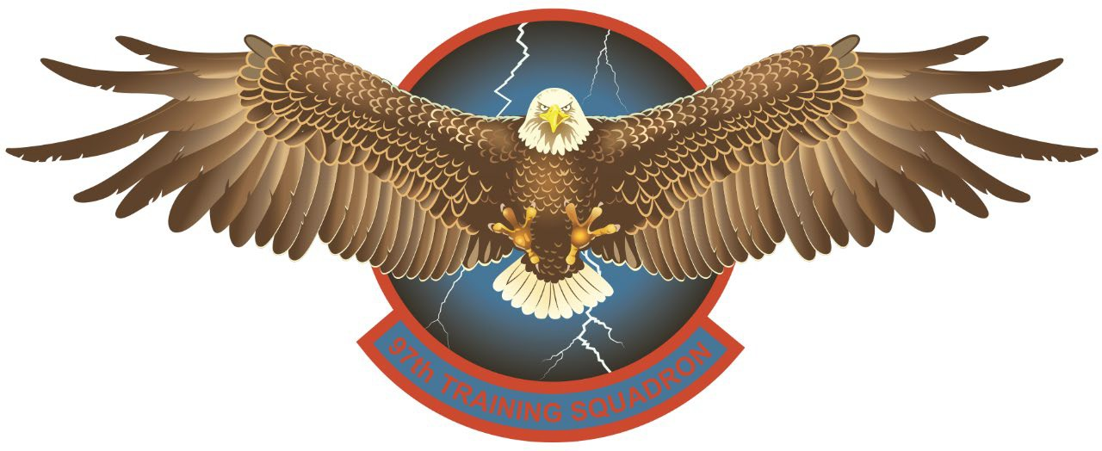

**Always Out Front!**

Revised: 12 May 2025

|  |
| --- |
| **Administrative Note: Noncompliance with Reporting Instructions or 97 AMW Policies may result in removal from training and/or disciplinary action.** |

**97th TRS/TRA: STUDENT ADMINISTRATIVE SUPPORT:** Student Admin is available Mon-Fri, 0730-1130 and 1230-1630 to assist with personal, professional, and training issues. Located on the First Floor of Building 87.

97 TRS/TRA (Student Admin): Commercial/DSN: 580-481-7446 / 866-7446

On-Call Flt/CC Cell: Commercial: 580-649-1490

AFRC Liaison: Commercial/DSN: 580-481-6891 / 866-6891

ANG Liaison: Commercial/DSN: 940-676-6812 / 736-6812

**SALESFORCE (SIMS) ACCOUNT SETUP: *Prior to arrival, all students are required to create an account in our student management database, Salesforce.*** For Salesforce activation, complete and sign SIMS Mobile Device Use Policy posted on our student website <https://www.altus.af.mil/About-Us/New-Students/> , save as "**Last Name, First Name – SIMS Mobile Device Use Policy** and include attachment in your Salesforce activation request email. **Requests will be sent from your .mil email account** to [97TRS.Inprocessing@us.af.mil](mailto:97TRS.Inprocessing@us.af.mil) about a month prior to your class start date. **Use this subject line format for all email traffic:** rank, first and last name, airframe/course, class start date. **(ex: Capt John P. Smith, C17PIQ, 4 Nov 2024).** Once we receive your SIMS Mobile Device Use Policy, we will activate your account, and you will receive an activation email and instructions on what to do next. Failure to activate your account will slow your in-processing and may result in being sent home for not meeting course prerequisites.

**COURSE DOCUMENTATION: *All required documents are to be submitted through Salesforce NLT 3 weeks prior to class start date.*** There are **TWO MANDATORY checklists** for all students (*except Non-Prior Service AiTs) to complete, which must be signed by unit CC or designee:

* *Altus Common Checklist*
* *Course-specific PreReq Checklist* (e.g. C-17 PCO PreReq Checklist)

Both checklists have a list of documents which must be provided to the 97 TRS via your Salesforce account.

**Prerequisites Checklists are available here**:

Altus Student Website:   
[http://www.altus.af.mil/About-Us/New-Students/](http://www.altus.af.mil/About-Us/New-Students/%20)

Education and Training Course Announcements (ETCA) Website (requires CAC access)  
<https://usaf.dps.mil/teams/app10-etca/SitePages/home.aspx?isdlg=1&IsDlg=1>

* Non-Prior Service AiTs only need to submit their orders, chamber card, and DD Form 2992 from their PHA (flight physical).

**WAIVERS:** Before departing for training, students who do not meet the required course prerequisites must obtain a waiver. Submit waivers via AETC Form 6 to appropriate approval authorities. Approval authorities vary based on the nature of the waiver. See sections below. Approval authorities are determined by 19 AF/CC Approval Authority Delegation Memorandum. Failure to receive a waiver required for course entry will result in removal from training.

**Syllabus Waivers and Syllabus Prerequisite Waivers:** The losing/home units will initiate waivers and coordinate through their local OG/CC (or equivalent) to MAJCOM/A3T (or equivalent) (**T-2).** MAJCOM/A3T (or equivalent) will forward to 19 AF Graduate Training Division MAF Branch. 19 AF Graduate Training Division MAF Branch will coordinate with applicable FTU and will forward to 19 AF Graduate Training Division for final approval. (ref. AETCI36-2605V7 2.2.3.1) Waivers requiring **19 AF approval must be submitted through the appropriate routing chain below, NLT 3 weeks prior to class start date.**

Routing Chain: *Requesting Squadron > Local OG > MAJCOM A3T > AETC Tasker Org Box* [aetc.tasker.workflow@us.af.mil](mailto:aetc.tasker.workflow@us.af.mil) > *19 AF Graduate Training Division MAF Branch > FTU Coordination > 19 AF Grad Division Final Approval*

**Senior Officer Syllabus and Entry Prerequisite Waivers:** Route waivers through MAJCOM/A3T (or equivalent) to 19 AF/DO (**T-2).**

**PHA and Altitude Chamber:** 19AF/DO delegates authority to the FTU WG/CC to waive the following syllabus prerequisites: Physical Health Assessment (PHA) and Physiological Training (Altitude Chamber), with concurrence of the OG/CC and that the Medical Group Commander will provide these events by the appropriate time. This does not constitute authority to waive flight required events. (ref. AETC36-2605V7 2.2.3.3) **Waivers requiring 97 AMW/CC approval must be submitted to the 97 TRS NLT 3 weeks prior to the class start date.**

Routing Chain: *Requesting Squadron > 97 TRS/TRA Workflow 97.trs.traworkflow@us.af.mil > 97 TRS/TRA > 97 TRS > 97 OG > 97 AMW final approval*

REPORTING TO TRAINING: Students will arrive at Altus AFB one day prior to class start date, and not earlier. *Exception:* Non-prior servicemembers (AiT) should arrive at least 3 duty days prior to class start date when their pipeline training schedule allows. *Students with unexpected travel delays must contact 97 TRS Student Admin ASAP (after duty hours, please call the On-Call Flt CC Cell at* 580-649-1490*).* Students will arrive at 0700 on their class start date for in-processing at 0715 in Building 87, Room 103, Student Admin.

LODGING: All students are required to stay in on-base lodging for the duration of their training (Red River Inn) IAW 97 AMW/CC policy and these reporting instructions. Failure to comply with Wing policy or reporting instructions may result in removal from training and/or disciplinary action. Students are encouraged to pursue Exception to Policy (ETP) requests for their unique circumstances. A list of commonly approved or denied Exception to Policy (ETP) requests is below. The list is not all-inclusive. ETP requests may be submitted to the 97 TRS/CC by the student’s unit CC or DO at the following link: <https://forms.osi.apps.mil/r/7WxkRudnzV>

Do not book lodging through DTS! Single lodging rooms are automatically reserved for students if the Red River Inn has availability. One week prior to arrival, students must call the Red River at (580-481-7356) to confirm their reservation or receive a Certificate of Non-Availability. The only students approved for the TLF lodging rate are students on accompanied orders (e.g. PCS enroute with dependents); unaccompanied students are not approved lodging in excess of the VOQ rate and shall not accept TLFs from the Red River Inn.

|  |  |
| --- | --- |
| Commonly Approved ETP Requests: | Commonly Denied ETP Requests: |
| * Student is bringing a spouse * Student is bringing children * Student is bringing a pet which would be financially burdensome to board (veterinary or adoption records will be required upon in-processing) | * Dietary restrictions (all lodging units have kitchenettes) * Crew integrity with training partner (not a syllabus requirement) * Student is renting an electric vehicle * “The JTR says I can” (see 97 AMW/JA determination below) * “After 30 days I lose Priority 1 status” (a non-availability letter would be issued to the person pursuing lodging) |

A Commander can implement a policy that is more restrictive [than] what is ordinarily authorized to servicemembers, so long as the Commander’s policy or order has some valid military nexus and isn’t prohibited by law or superior order.  In our situation, 97 AMW/CC has a justifiable basis (based on the needs of his command) for requiring students to use the [Integrated Lodging Program], and the JTR does not categorically prohibit a Commander’s more restrictive lodging policy.  The Commander isn’t taking away an entitlement that’s authorized by Title 37—he’s merely directing where students need to go first for lodging.  In short, although it may be more restrictive than what’s typically allowed, it’s a lawful order. This is analogous to many other situations where commanders restrict what’s otherwise authorized, e.g.:

* A commander prohibiting off-duty employment based on the needs of his/her squadron.
* General Orders prohibiting otherwise permissible conduct based on the needs of the AOR.
* Other TDY locations that require government lodging (Nellis Weapons School, Maxwell courses, etc.)

FLIGHT EQUIPMENT/UNIFORMS:

* At least 2 Flight Suits (FDU or 2PFDU), Flight Gloves, Safe-to-Fly (STF) Boots, Flight Jacket
* Flashlight, reflective belt, dog tags
* Headset (will be issued if in an initial course)
* Helmet (Required for any C-17 course except for ILM and SOC)
* Calculator & Tape Measure (12’) (Loadmaster or Boom Operator courses)
* Prescription aircrew glasses/corrective lenses (must be on the contact lens program)
* Cold weather gear for courses occurring between October and April

All Airmen in Training (non-prior service) BIQ/LIQ students will be issued necessary equipment by 97th TRS/Student Affairs. For prior service students attending BIQ/LIQ, as well as students attending other courses, equipment is limited and *will be provided by the student’s gaining unit prior to attending training*. Students attending training during the cold weather period from 01 October to 31 March will require cold weather gear. Students who arrive without the required equipment will need to request equipment issue from Lighthouse in coordination with their gaining unit’s GPC holder. All PIQ students will ensure they are issued all flight equipment, to include cold weather gear, prior to departing their UPT unit.

**PUBLICATIONS:** If not completed within the past year, all students are required to complete the “Using Mobile Devices in a DoD Environment” CBT at the following link:

<https://dl.dod.cyber.mil/wp-content/uploads/trn/online/dod-mobile-devices/launchPage.htm>

* Students who **HAVE** been issued an EFB (iPad) from their home-station will bring it with them to Altus.
* Students who **HAVE NOT** been issued an EFB (iPad) will be issued one from the Pubs Office. All loaned EFBs MUST be returned at or prior to out-processing.

Students must provide a copy of the DoD Mobile Devices CBT completion certificate **dated within the past year, and** **with their name on it**. Failure to produce a certificate will delay class start, as an EFB account cannot be provisioned and an EFB cannot be issued until the certificate is presented.

**FUNDING:** Government meals are available. TDYs en-route to PCS are the responsibility of the gaining units. There are no training out-and-backs from Altus. For fund cite information, please contact your local or gaining unit DTS Approval Authority.

**GOVERNMENT MEALS:** Students have access to flight meals ordered from the Hangar 97 DFAC for **all** aircraft sorties, which must be ordered for pickup from the DFAC at 580-481-7781. Flight meals must be ordered no later than the day prior for morning flights; they may be ordered up to 2 hours prior to show time for night flights. DFAC Operating Hours can be found at <https://altusfss.com/hangar97>

**MISSED MEALS:** IAW JTR Chapter 2, home unit AOs are responsible for missed meal approval. Concurrence should come from a home-unit approving official, or other SQ/CC designee. Students are individually responsible for retaining supporting documentation relating to missed meals; copies of class and simulator schedules may be required by home unit policy. **97 TRS members will not sign missed meal forms, nor will they collect individual student schedules or sortie data for missed meal validation.**

**FITNESS:** AETCI 36-2605v7 Altus AFB Sup states: “Students will not be given fitness assessments while training at Altus AFB unless coordinated and approved by 97 TRS/CC prior to the start of training.” Students must arrive at AAFB with a current fitness test. DAFMAN 36-2905, para 3.7 lists the following categories as current:

3.7.1. Performed an Excellent PFA within the last 12 months.

3.7.2. Performed a Satisfactory PFA within the last 6 months.

Note: 12 months for ANG Title 32 Drill Status Guardsmen.

3.7.3. Performed an Unsatisfactory PFA within the last 90 days.

3.7.4. Presently under a Composite Exemption.

Additionally, students enrolled in the Fitness Improvement Program following a PT test failure must comply with the following requirements:

1. DAFMAN 36-2905, para 5.4.7. – “Commanders sending members enrolled in the FIP to a training TDY that exceeds six weeks must send the gaining commander or equivalent a memorandum explaining the required intervention, follow-up, and assessment at least two weeks prior to TDY. (T-2).”
2. AETCI 36-2605v7 Altus AFB Sup, para 2.5.1.  (Added-ALTUSAFB) – “Members enrolled in FIP may attend training provided their retest date (failure date plus 90 days) is greater than their course graduation date plus fifteen calendar days, and their FIP is approved by the 97 TRS/CC. FIPs will not be approved that require organized physical training events.”

SECURITY CLEARANCES: A valid security clearance is a prerequisite for ALL formal courses. Security managers will confirm valid security clearance on the Altus Common Prerequisite Checklist. Altus AFB does not have the authority to issue security clearances to students per AFI31-501. Security clearances (SECRET, Continuous Evaluation, or Interim) must be obtained prior to class start date or the student will NOT be allowed to attend class. Students should not proceed to Altus AFB for training until DISS or JPAS displays a valid clearance.

**STUDENT HANDBOOK:** All students training at Altus AFB are administratively assigned to the 97th Training Squadron and are expected to adhere to the UCMJ, Air Force Instructions, and the Student Handbook.

**Student Handbook available here**:

Altus Student Website [http://www.altus.af.mil/About-Us/New-Students/](http://www.altus.af.mil/About-Us/New-Students/%20)

**HOLIDAY EXODUS:** Altus AFB flying operations shut down during Thanksgiving and Christmas/New Year holiday periods. Actual dates of these breaks in flying training will be published once they are finalized by AETC. The schedule is typically not finalized until a few days prior to the start of the holiday break, therefore **students should not plan on departing Altus AFB until the first day of the break.**

Thanksgiving Passes are available from Thursday to Sunday. This requires no leave request and is not charged to the member. Passes must be approved in Salesforce for accountability purposes. Leave outside of these dates will be reviewed per the 97 TRS Pass/Leave policy.

All Active Duty, AFRC, and ANG students are given multiple options available during their December holiday break. Specific details will be published in an EXODUS Memorandum NLT 1 November. If the Memorandum has not been published by 1 November, please contact 97 TRS/Student Admin.

**STUDENT PASS AND LEAVE POLICY:**

Please refer to the current student pass & leave policy on the Altus Student Website. <http://www.altus.af.mil/About-Us/New-Students/>